I’m attaching all the screenshots of the following

* New custom VPC
* Configured my EC2 linux instance inside your custom VPC
* Created 3 subnets of that VPC
* Attached an internet gateway to your custom VPC

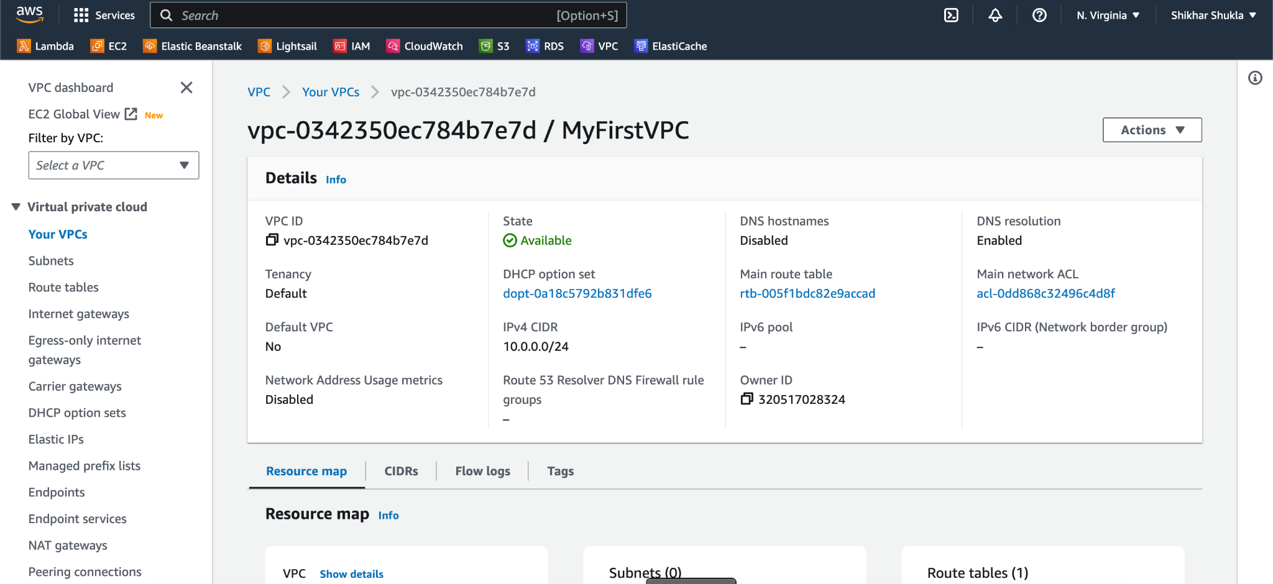  
  
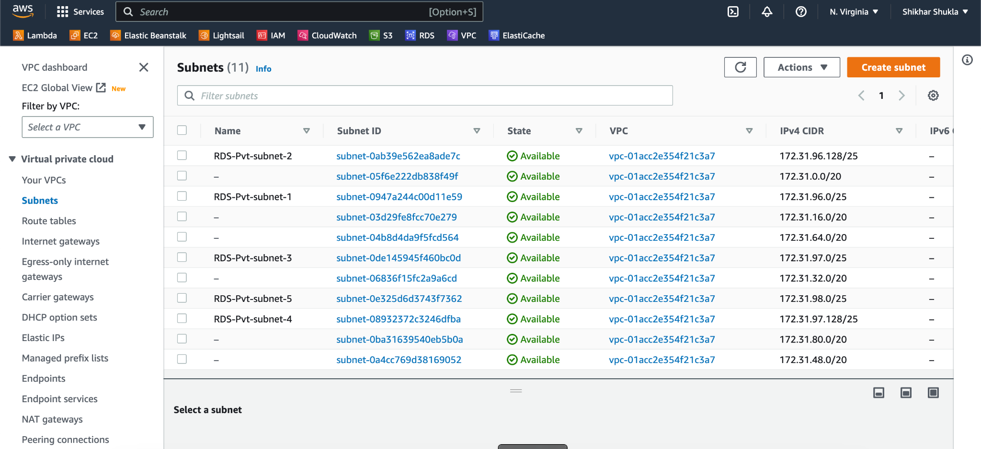

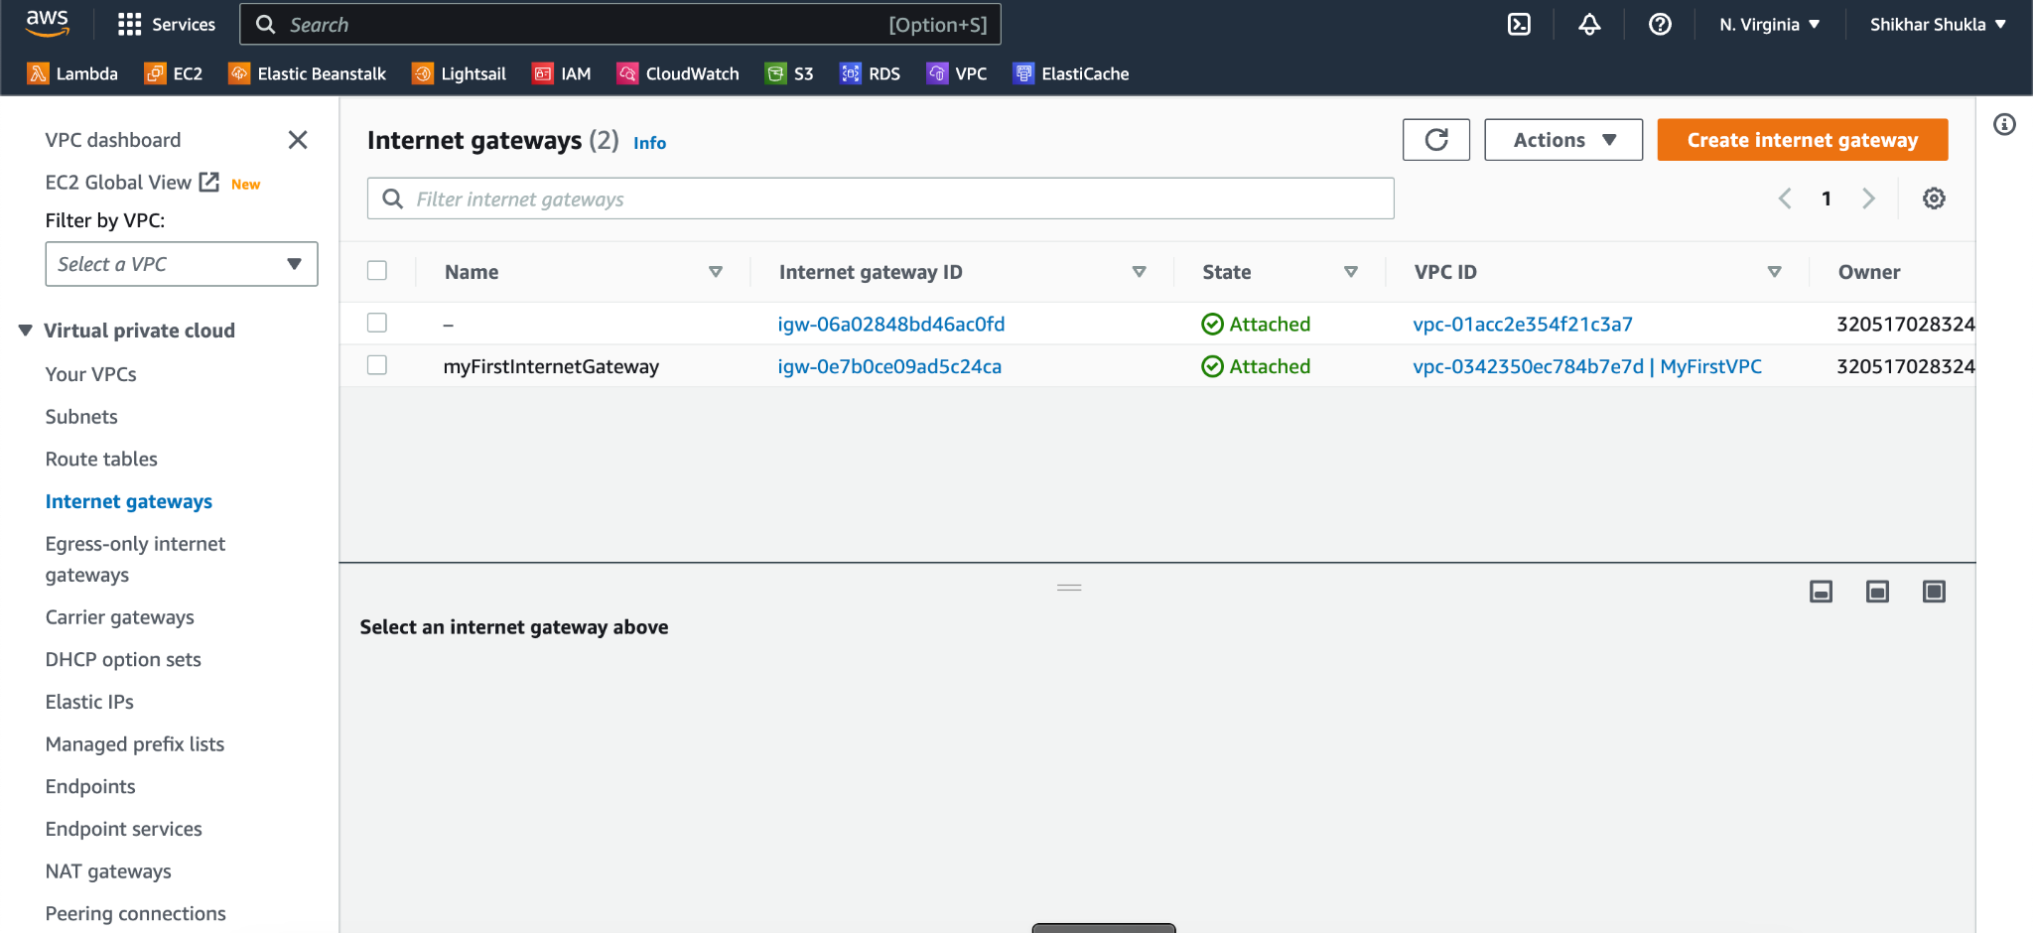  
  
I’ve Launched a new EC2 instance and chose the VPC I just created in the "Network" section of the launch wizard.

Then I chose the appropriate subnet for my instance and completed the instance launch.